Design/Build Institute of America
Rocky Mountain Region – Water/Wastewater Committee

Project Delivery Selection Approach

Overview

This document provides an approach for water and wastewater project delivery method evaluation and selection. Template forms are attached for use by owner organization staff and practitioner project team members. By using these forms, a brief project delivery selection summary may be generated for individual projects. The primary objectives of this document are:

- Present a structured approach to assist owner organizations of water and wastewater systems in making project delivery method decisions;
- Assist the owner organization in determining if there is a foremost or obvious choice of project delivery method; and
- Provide documentation of the project delivery method decision in the form of a Project Delivery Decision Report.

Background

Project delivery is the process by which a project is comprehensively designed and constructed including project scope definition, organization of designers, builders and various practitioners and their contracting relationships, sequencing of design and construction operations, execution of design and construction, and closeout and start-up. Differences in project delivery methods are distinguished by the manner in which contracts between the owner organizations, designers and builders are formed, and the relationships that are established between each party based on the contracts. Currently, there are several types of project delivery methods available for publicly and privately funded projects in Colorado. Individual owner organizations have varying procurement processes and requirements related to project delivery methods.

The most common water and wastewater project delivery methods are:
- Design/Bid/Build (D/B/B)
- Construction Management At-Risk (CMAR)
- Progressive Design/Build
- Prescriptive-Based Design/Build

Less frequently implemented forms of water and wastewater project delivery methods are:
- Performance-Based Design/Build
- Engineer-Procure-Construction Manager (EPCM)
- Job Order Contracting (JOC)
- Design-Build-Operate (DBO)
- Design-Build-Finance-Operate (DBFO)
- Design-Build-Own-Operate-Transfer (DBOOT)

Alternative Project Delivery Methodology Comparative Matrix

The Alternative Project Delivery Methodology Comparative Matrix (pages 4-5) summarizes the distinctions between the project delivery methods.

The following primary differentiators between traditional design/bid/build projects in comparison to alternative delivery projects, among others, are illustrated in the Matrix.
- Involvement of construction personnel early in the project design phase to proactively identify and resolve potential constructability, schedule, and quality issues prior to beginning field work.
- Opportunity to select the design/builder based on overall best value considering a comprehensive range of selection criteria, including quality, schedule, risk, and cost factors.
- Best value selection for major equipment and subcontractor procurements may be completed during the progression of the design phase.
- For Progressive Design/Build and Prescriptive Design/Build, single-point accountability for both design and construction.
- Early knowledge and certainty of total project costs.

Distinction between Progressive and Prescriptive-Based Design/Build

In Progressive Design/Build, the owner selects the design/builder based on qualifications or best value, then works with the design/builder to progress the design to a level where the owner then requests the design/builder to submit a price for completing the final design and construction. For a Prescriptive-Based Design/Build project, the design/builder agrees to design and construct the project for a fixed price, and the service provider’s price is based on the owner’s description of the project requirements or on a conceptual design provided in the procurement documents.

Overview of the Project Delivery Selection Process

The Project Delivery Selection Process consists of the following elements:

- Describe the project and set the project goals
- Determine and review project-dependent constraints
- Determine the Evaluation Criteria that affect the selection of project delivery method. Evaluation Criteria Definitions are provided in Table 1 (page 6).
  - Level of Control
    - O&M/Equipment Selection Considerations
    - Design/Sustainability
    - Level of Owner Control
    - Project Quality
    - Owner Resources (staffing and knowledge of project delivery)
  - Schedule
    - Implementation Schedule
    - Construction and Operational Flexibility

  - Cost
    - Cost Competitiveness
    - Cash Flow
    - Cost Certainty
    - Market and Industry Visibility
  - Risk
    - Project Size and Complexity
    - Impact on Public
    - Legislative and Legal
    - Allocation
    - Regulatory Compliance
    - Right-of-Way and Environmental Permitting Control
  - Level of Design completed at the time of the procurement
  - If the Evaluation Criteria indicates there is a clear choice of the delivery method, then perform an initial risk assessment for the desired delivery method to ensure that risks can be properly allocated and managed.
Typically the entire selection process can be completed by the project team in a 4-hour workshop session, if individual team members have familiarity with the alternative project delivery methods and have performed assessments before the workshop.

Evaluation Criteria Ranking Summary

Table 2, Evaluation Criteria Ranking Summary (page 7), summarizes the assessment of the Evaluation Criteria for the project delivery methods. The form is qualitatively scored using the scoring provided below.
Evaluation Criteria Scoring Key
+ + | Most appropriate delivery method
+ | Appropriate delivery method
– | Least appropriate delivery method
X | Fatal Flaw (discontinue evaluation of this method)
NA | Factor not applicable or not relevant to the selection

The form also includes a section for comments and conclusions. The completed Evaluation Criteria Ranking Summary provides an executive summary of the key reasons for the selection of the project delivery method.

Reference
It is suggested that owner organizations of water and wastewater systems review The Municipal Water and Wastewater Design-Build Handbook published by the Water Design-Build Council for additional information on evaluating whether it is appropriate to use alternative project delivery methods, and if so, how to use them effectively.

ALTERNATIVE PROJECT DELIVERY METHODOLOGY – COMPARATIVE MATRIX |  | 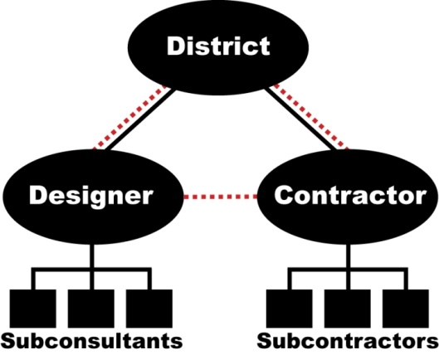  Owner | Owner | 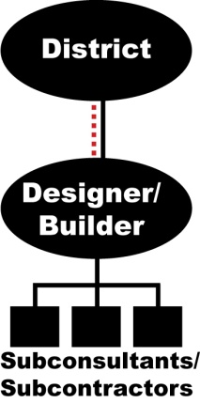  Owner | Owner
 |  | Design/Bid/Build  (D/B/B) | Construction Management-At-Risk  (CMAR) | Progressive Design/Build  (D/B) | Prescriptive-Based Design/Build  (D/B)
ALTERNATE TERMINOLOGY |  | Competitive Bidding or Hard Bid | Construction Manager / General Contractor  (CM/GC) | -- | Lump Sum Design/Build,  Engineer-Procure-Construct (EPC)
GENERAL DESCRIPTION |  | A project delivery method where the owner selects an engineer to design and develop construction documents, from which the owner solicits lump sum bids. Selection is based on the lowest responsive bid, and the contractor serves as a single point of responsibility for construction. The owner procurement rules allow some variations to the “traditional” design/bid/build project delivery method in order to increase level of "control" of certain project elements, if desired. Options include potential pre-qualification of contractors and/or specific suppliers, pre-selection and/or pre-purchase of selected equipment, or other non-standard variations. Selection is based on the lowest responsive bid and the contractor serves as a single point of responsibility for construction. | A project delivery method where the construction manager serves as the general contractor providing pre-construction and construction services, while the engineer completes design under a separate contract, with the intent of promoting enhanced collaboration between all parties during design development. Qualification-based selection (QBS) of the CMAR or CM/GC is typically done early in the design process. If no acceptable GMP is reached, the owner still maintains the option to bid out the construction work. | A project delivery method that uses a qualifications-based selection (QBS, often with a proposed fee structure) similar to CMAR or CM/GC, but combines separate design and construction procurements into one procurement and selection of a single-contract design/build entity. Once selected, design commences and a construction estimate is "progressively" developed in an open-book format until a price can be agreed upon between the design/builder and owner. If no acceptable GMP or Stipulated Price is reached, the owner still maintains the option to bid-out the construction work. | A project delivery method that typically uses a two-step procurement process, requiring short-listed design/builders to propose lump sum solutions based on the owner’s specifications and project concept, usually using a design developed by others provided in the RFP. The selected design/builder works under a single contract and is required to deliver a facility that meets the owner’s specifications at the proposed price.
PRICING STRUCTURE |  | Fixed Bid Price (Lump Sum) | Negotiated GMP | Negotiated GMP or Stipulated Price | Fixed Price (Lump Sum)
TOOLS / ELEMENTS
Method | Legislative / Regulatory
 | State of Colorado | ALLOWED | ALLOWED | ALLOWED | ALLOWED
 | Selection Process
 | Qualifications-Based | NO | YES | YES | YES
 | Price-Based | YES | POSSIBLE - BEST VALUE | POSSIBLE - BEST VALUE | YES
 | Pre-Selection | POSSIBLE AS A VARIATION | POSSIBLE | POSSIBLE | POSSIBLE
 | Pre-Purchase (by Owner) | POSSIBLE AS A VARIATION | POSSIBLE | POSSIBLE | POSSIBLE
 | Pre-Purchase (by Contractor) | NO | POSSIBLE | POSSIBLE | POSSIBLE
Implementation | Pre-Qualification
 | General Contractors | POSSIBLE AS A VARIATION | RECOMMENDED FOR CMAR | RECOMMENDED FOR D/B TEAM- | RECOMMENDED FOR D/B TEAM
 | Subcontractors | POSSIBLE FOR MAJOR | POSSIBLE | RECOMMENDED FOR MAJOR | RECOMMENDED FOR MAJOR
 | Suppliers | POSSIBLE AS A VARIATION | RECOMMENDED FOR KEY EQUIPMENT | RECOMMENDED FOR KEY EQUIPMENT | POSSIBLE FOR KEY EQUIPMENT
 | Multiple Contracts | POSSIBLE AS A VARIATION | NOT LIKELY | NOT LIKELY | NOT LIKELY
 | Multiple Phases | NOT WELL SUITED | POSSIBLE | POSSIBLE | POSSIBLE
 | Incentives  Contractual Relationship Working Relationship | POSSIBLE | POSSIBLE | POSSIBLE | POSSIBLE
Contractual Relationship Working Relationship

